**Shortcomings**

Our DeepSenseNet was overfit to the training data, this can be easily interpreted from the high classification accuracy on the training set and low accuracy on validation data. Another major problem is the arbitrary validation set, we did not use k fold cross-validation as it would require multiplying training time by the multiplier k. Additionally we have observed saturation in some of the convolutional layers even after normalizing each one of them.

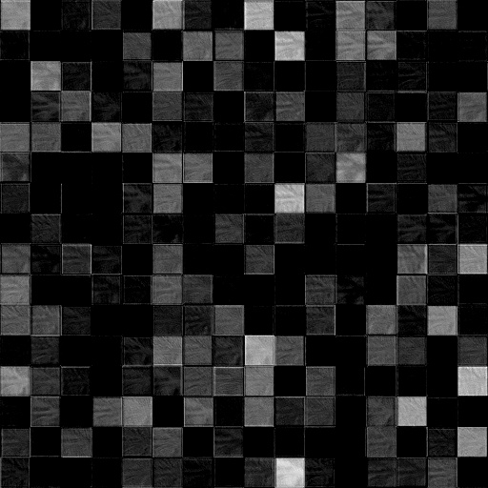

Figure X: Output of a convolutional layer

Each one of the squares in the above image corresponds to a feature detected by a feature in the conv net. Many of the squares are completely black meaning the neurons are dead and cannot be brought back even with very strong multipliers. This is because of a known property of the ReLU activation function of multiplying negative result by zero [ref to some paper]. Other activation functions have other downsides also considered during the design phase of this project.



Figure X: Saliency maps of two distinct images

(drawn as heat map with red contributing more to classification than blue)

To analyze the features that our network was learning from we drew a saliency map of a sample image. The results were disappointing as the hot areas of the saliency maps were showing that noisy areas were contributing more to classification than the desired features.